Title: **What was the loop hole in security during Pulwama Attack?**

Link: https://www.quora.com/What-was-the-loop-hole-in-security-during-Pulwama-Attack

Points:

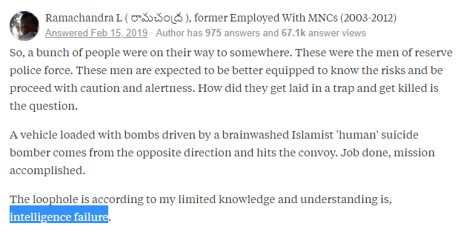

Title: **44 CRPF jawans killed, 70 injured in Pulwama terror attack in J&K**

Link: https://www.livemint.com/news/india/pulwama-terror-attack-death-toll-rises-to-40-jem-claims-responsibility-1550143395449.html

Points:

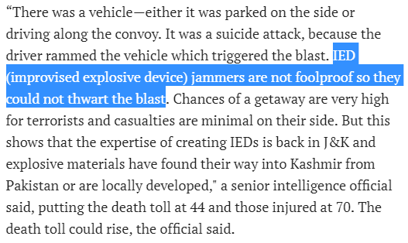

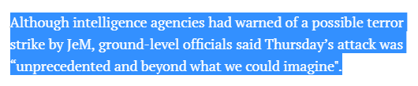

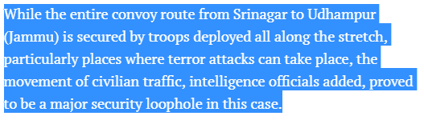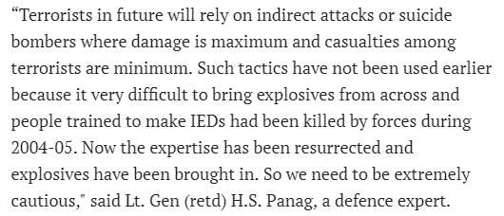

Title: Security & intelligence experts raise questions on several lapses, want accountability to be fixed, and favor reopening of political dialogue on Kashmir.

Link:

Points:

